**ASSIGNMENT-8.4**

NAME:-E.HARINI,

BRANCH: -CSE,

ROLLNUMBER: 2503A51L40,

Course : AI ASSISTED CODING;

**TASK1:**

Write a test case to check if a function returns the square of a number.

**1.PROMPT:-**

Test if the function square(num) returns the square of the input number.

**2.CODE:**

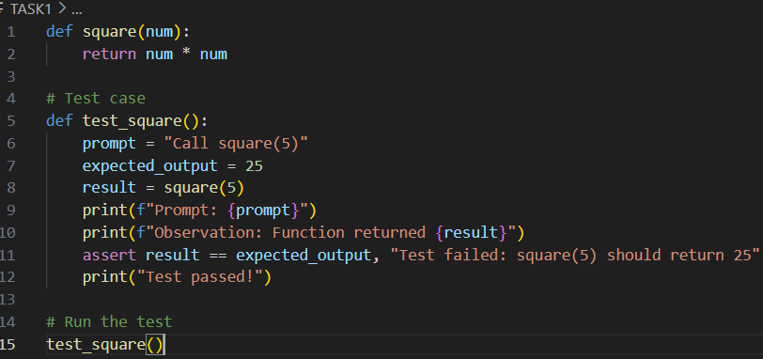

**3.OUTPUT:**

**4.OBSERVATION:**

If the function returns 25 when input is 5, the test passes, confirming the function correctly calculates the square of a number. If it returns any other value, the test fails.

**TASK2:**

Create test cases to validate an email address (e.g., contains @ and .com)

**1.PROMPT:**

Test if the function is_valid_email(email) correctly validates an email address by checking if it contains @ and ends with .com.

**2.Code:**

**3.output:**

**4.observation:**

The function returns True for "user@example.com", the test passes, confirming that the function correctly validates a standard email address. If it returns False, the test fails .

**Task3**:

Write test cases for a function that returns the maximum of three numbers.

**1.Prompt:**

**2.Code:**

**3.output:**

**4.observati0n:**

I have observed that positive and negative numbers .

**Task4:**

Use TDD to write a shopping cart class with methods to add, remove, and get total price.

**1.Prompt:**

Tests fail because Shopping Cart does not exist.

**2.Code:**

**3.Output:**

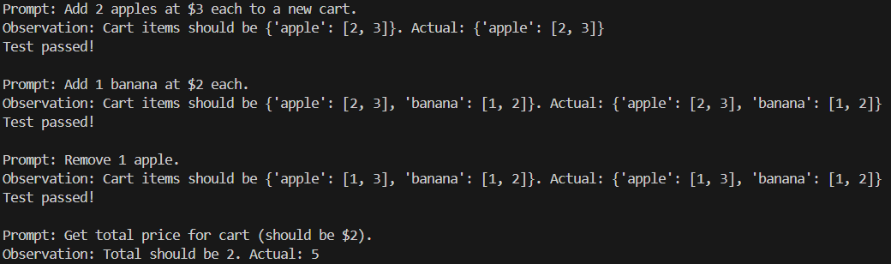

**4.Observation:**

TDD helped us define clear requirements (add, remove, total) before writing logic.

**Task5**: Write tests for a palindrome checker (e.g., is palindrome("level") → True)

**1.Prompt:**

Give a palindrome checker if true or false .

**2.Code:**

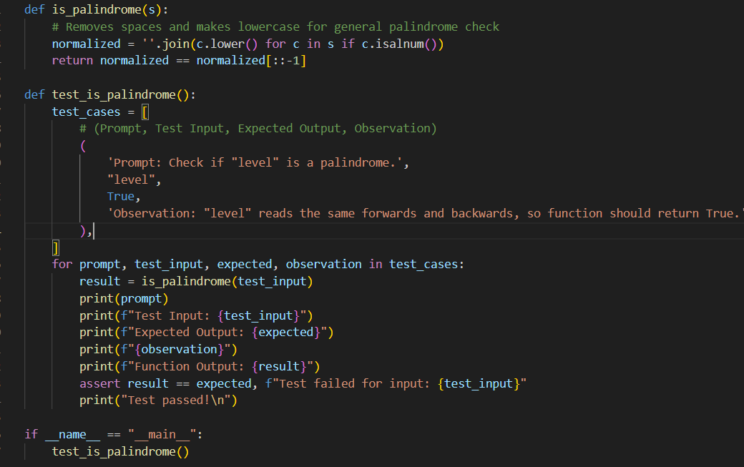

**3.output:**

**4.observation:**

Start with simple palindrome check.Add tests for edge cases (empty string, single char).Improve function to handle mixed case & punctuation.Final function satisfies all requirements.